1

GhostNet: LLM-Driven Legacy Twin Using Multi-Modal Personal Data Embedding

MICRO PROJECT REPORT

Submitted by

ARTHI SANTHANALAKSHMI RegisterNo:23UCB003
JAYASRI R RegisterNo:23UCB023
KEERTHANA K RegisterNo:23UCB030
SWATHI J RegisterNo:23UCB054

Under the guidance of

Mrs. E. THAMIZHARASI
In partial fulfillment of the requirements for the degree of
BACHELOR OF TECHNOLOGY



DEPARTMENT OF COMPUTER SCIENCE AND BUSINESS SYSTEMS
SRI MANAKULA VINAYAGAR ENGINEERING COLLEGE

(An Autonomous Institution) MADAGADIPET, PUDUCHERRY-605107
October - 2025

SRI MANAKULA VINAYAGAR ENGINEERING COLLEGE
(An Autonomous Institution)

DEPARTMENT OF COMPUTER SCIENCE AND BUSINESS SYSTEMS

BONAFIDE CERTIFICATE

This is to certify that this Micro Project work entitled “GhostNet – Your AI Legacy Tw GhostNet: LLM-Driven Legacy Twin Using Multi-Modal Personal Data Embedding in” is a bonafide record of work done by ARTHI SANTHANALAKSHMI [23UCB003], JAYASRI R [23UCB023], KEERTHANA K [23UCB030], SWATHI J [23UCB054] of III Year / V Semester during the academic year 2025-2026.

This work has not been submitted elsewhere for the award of any other degree to the best of our knowledge.

PROJECT CO-ORDINATOR HEAD OF THE DEPARTMENT
Mrs. E. THAMIZHARASI, Dr. M. AUXILIA ,
Assistant Professor , Department of CSEBS, Professor & Head, Department of CSEBS, Sri Manakula Vinayagar Engg. College, Sri Manakula Vinayagar Engg. College, Madagadipet, Puducherry - 605 107. Madagadipet, Puducherry - 605 107.

Submitted for the End Semester Practical Examination held on

INTERNAL EXAMINER

ACKNOWLEDGMENT

We wish to express our sincere thanks to our project coordinator Mrs. E. THAMIZHARASI, Assistant Professor, Department of CSEBS, for her guidance and help rendered for the successful completion of our project.

We wish to express our sincere gratitude to our respected Director Cum Principal, Dr.V.S.K. VENKATACHALAPATHY, Sri Manakula Vinayagar Engineering College, for giving us the opportunity to provide the infrastructure and facilities for my project.

We wish to thank all the faculty members of the Department of CSEBS, Sri Manakula Vinayagar Engineering College for the valuable information provided by them in their respective fields.

We also take this opportunity to thank our respected Chairman and Managing Director Shri. M. DHANASEKARAN, Secretary Shri. Dr. K. NARAYANASAMY, Treasurer D. RAJARAJAN and Management Staff for their contribution to this project.

We also express our gratitude towards our Parents for their support, Motivation, and Encouragement in effectively getting through the project and the course.

We take this opportunity to express my sincere thanks to The Almighty from the depth of my heart who their valuable guidance and encouragement for the successful completion of this project.

ARTHI SANTHANALAKSHMI
JAYASRI R
KEERTHANA K
SWATHI J

ABSTRACT

GhostNet: LLM-Driven Legacy Twin Using Multi-Modal Personal Data Embedding is an innovative emotional intelligence system that uses Artificial Intelligence and multimodal analysis to understand and predict human emotions. By combining text, voice, and facial expression data, the system builds a personalized Mood DNA — an evolving emotional fingerprint that helps users visualize and track their emotional patterns over time. The platform’s AI-powered Emotional Twin chatbot reflects the user’s emotional personality, offering empathetic interactions, mental health insights, and predictive recommendations.

Built using FastAPI for the backend and React for the frontend, Ghostnet integrates deep learning models such as DistilBERT for text, SpeechBrain for voice tone, and DeepFace for facial emotion detection. With predictive analytics powered by LSTM networks, the system forecasts future emotional states, detects burnout risks, and visualizes emotion trends. Ensuring data privacy and ethical AI use, Ghostnet bridges technology and psychology to promote emotional awareness, resilience, and self-reflection in a digital age..

TABLE OF CONTENTS
CHAPTER NO. | TITLE | PAGE NO.
 | ABSTRACT | 0
1 | INTRODUCTION
 | 1.1 ABOUT THE DOMAIN | 6
 | 1.2 PROBLEMS IN EXISTING SYSTEM | 7
 | PROBLEM DEFINITION
2 | 2.1 PROBLEM STATEMENT | 8
 | 2.2 OBJECTIVES | 8
 | 2.3 EXISTING MODEL | 9
 | 2.4 LITERATURE SURVEY | 10
 | REQUIREMENT SPECIFICATION
3 | 3.1 REQUIREMENT ANALYSIS | 13
 | 3.2 MODEL REQUIREMENT | 13
 | ARCHITECTURE
4 | 4.1 PROPOSED SYSTEM ARCHITECTURE | 14
 | 4.2 RULE-BASED MODULE | 19
 | IMPLEMENTATION AND RESULTS
5 | 5.1 MODEL DESCRIPTION | 20
 | 5.2 IMPLEMENTATION SCREENSHOT | 21
 | 5.3 COMPARISON BETWEEN EXISTING MODEL AND PROPOSED MODEL | 22
 | 5.4 PERFORMANCE METRICS EVALUATION | 23
 | 5.5 GRAPHICAL COMPARISON | 24
 | CONCLUSION
6 | 6.1 CONCLUSION | 25
 | 6.2 FUTURE SCOPE | 26
 | 6.3 REFERENCE | 26
 | APPENDIX A | 27
 | APPENDIX B | 51
 | LIST OF FIGURES | 53
 | LIST OF ABREVATION | 53

CHAPTER 1 INTRODUCTION

  - ABOUT THE DOMAIN

The domain of the GhostNet: LLM-Driven Legacy Twin Using Multi-Modal Personal Data Embedding project lies in the intersection of Artificial Intelligence (AI), Affective Computing, and Human–Computer Interaction (HCI). This domain focuses on creating intelligent systems that can recognize, analyze, and respond to human emotions using data-driven insights and adaptive learning.

The project explores how AI can enhance emotional understanding through multiple data modalities — such as text, voice, and facial expressions — to form a complete picture of human emotion.

Key domains and focus areas include:

Affective Computing

Focuses on developing systems that detect and interpret human emotions.

Uses multimodal inputs like speech tone, facial expressions, and text sentiment for accurate emotion recognition.

Artificial Intelligence and Machine Learning

Employs deep learning models to classify emotions into categories such as joy, sadness, anger, fear, and surprise.

Uses Natural Language Processing (NLP), speech analysis, and computer vision to interpret user inputs intelligently.

Multimodal Emotion Recognition

Combines data from multiple sources (text, voice, face) to improve emotional detection accuracy.

Reduces dependency on a single modality and ensures context-aware emotion analysis.

Predictive Emotional Analytics

Applies time-series models such as Long Short-Term Memory (LSTM) networks to forecast future emotional states.

Helps identify emotional patterns, burnout risks, and behavioral shifts over time.

Mood DNA Graph Visualization

Represents the user’s emotional history through dynamic color-coded graphs.

Displays emotion fluctuations, dominant moods, and overall mental wellness trends.

AI Emotional Twin

A personalized chatbot trained on user emotion data that reflects their communication style.

Provides emotionally adaptive responses and helps users develop self-awareness through conversations.

Ethical AI and Privacy

Ensures secure handling of emotional data using encryption and privacy protocols.

Offers optional on-device emotion processing for complete data confidentiality.

Applications

Mental Wellness Monitoring – Helps users understand their emotional patterns.

Virtual Companions – Empathetic AI chatbots for emotional support.

Employee Wellness – Assists organizations in tracking emotional health trends.

Educational Platforms – Supports emotional learning and student well-being

PROBLEMS IN EXISTING SYSTEM

- Limited Accuracy in Emotion Detection
Most existing emotion recognition systems rely on a single modality (text, speech, or face),
leading to incomplete or inaccurate emotional analysis.

- Lack of Personalization
Current tools often provide generalized results without considering an individual’s unique
emotional history or behavioral trends.

- Absence of Predictive Analysis
Traditional sentiment tools can detect current emotions but fail to forecast future emotional states
or risks such as burnout.

- Inadequate Visualization
Existing platforms rarely offer visual insights like mood graphs or emotional timelines that help
Users reflect on long-term change

CHAPTER 2

PROBLEM DEFINITION
  - PROBLEM STATEMENT

The Ghostnet – Your AI Legacy Twin project aims to address the challenges in emotional AI systems by creating a comprehensive platform that not only detects but also understands, visualizes, and predicts human emotions. While existing emotion recognition models are able to identify basic sentiments, they often fail to provide a personalized, context-aware, and predictive emotional understanding of users.
The main challenges identified are:
- Limited Emotional Depth
  - Existing systems rely on single input modes (text-only or face-only), resulting in incomplete emotional interpretations.

- Lack of Personalization
  - Current tools do not adapt to the user’s unique emotional history or communication style.

- Absence of Predictive Insights
  - Most emotion-tracking systems can identify emotions but cannot forecast future emotional trends or burnout risks.

- Inadequate Visualization
  - There is no structured visual representation such as emotional timelines or mood graphs that help users reflect on their mental states.

- Data Privacy Concerns
  - Many emotional analysis platforms lack secure handling and encryption of sensitive user data.
Hence, there is a need for a more intelligent, privacy-aware, and predictive emotional AI system that can understand users holistically and assist them in self-awareness and emotional regulation.

OBJECTIVES

The objectives of the Ghostnet – Your AI Legacy Twin project are:
- Multimodal Emotion Recognition
  - To analyze emotional states through text, voice, and facial expressions using AI and deep learning techniques.

- Creation of Mood DNA Graph
  - To generate a personalized visual representation of users’ emotional patterns that evolves over time.

- AI Emotional Twin Chatbot
  - To build a conversational AI twin that reflects the user’s emotional personality and provides empathetic interaction.

- Predictive Emotional Analytics
  - To employ LSTM models to forecast emotional trends and detect potential burnout or emotional decline.

- Real-time Emotion Tracking and Visualization
  - To monitor user emotions continuously and display insights through interactive graphs and charts.

- Ethical AI and Data Security
  - To ensure user emotional data is protected through encryption, local processing options, and transparent privacy measures.

- Enhanced User Well-being
  - To help users achieve emotional balance, self-awareness, and improved mental wellness through AI-driven feedback.

EXISTING MODEL

The existing emotional recognition systems and sentiment analyzers exhibit the following
characteristics and limitations:

- Single-Modality Input – Analyze only text or speech, leading to incomplete emotion prediction.
- Keyword-Based Analysis – Depend on predefined emotional keywords rather than contextual understanding.
- Static Response Mechanisms – Provide predefined or generic emotional responses without personalization.
- No Emotional Forecasting – Cannot identify trends or future emotional states.
- Limited Visualization – Lack advanced data visualization tools such as emotional graphs or time-based emotion tracking.
- Privacy Issues – Store emotional data in unsecured environments without encryption or transparency.

These limitations highlight the necessity for an integrated, multimodal, and secure
emotional AI framework like Ghostnet that delivers personalized and predictive emotion understanding.

  - LITERATURE SURVEY

[1] Author Name: Feng Lu, Bo Liu
Title of the Paper: Affective Digital Twins for Digital Human: Bridging the Gap in Human-Machine Affective Interaction
Summary:
This paper introduces the concept of "Affective Digital Twins," emphasizing the need for digital humans to possess realistic emotional traits to facilitate genuine human-AI interactions. It discusses key technical challenges such as affective modelling, perception, encoding, and expression, which are critical for developing emotionally aware AI systems like GhostNet.
[2] Author Name: S. Davila-Gonzalez, et al.
Title of the Paper: Human Digital Twin in Industry 5.0: A Holistic Approach to Human-Centric Manufacturing
Summary:
This study explores the integration of human digital twins in Industry 5.0, focusing on the collection of data related to mental, emotional, and physical aspects of human behaviour. It highlights the importance of creating personalized and adaptive systems that can respond to individual needs, aligning with the objectives of GhostNet to develop an emotionally intelligent digital twin.

[3] Author Name: Yujia Lin, et al.
Title of the Paper: Human Digital Twin: A Survey
Summary:
This comprehensive survey examines the underlying technologies and frameworks of human digital twins. It proposes a generic architecture for human digital twin systems and describes core function blocks and corresponding technologies, providing valuable insights for the development of personalized and adaptive AI systems like GhostNet.

Table 2.1: Literature Survey

S.no | Researcher Name | Paper Title | Concept | Advantages | Disadvantages
1 | Feng Lu, Bo Liu | Affective Digital Twins for Digital Human: Bridging the Gap in Human-Machine Affective Interaction | Introduces Affective Digital Twins that simulate realistic emotional traits in digital humans to facilitate genuine human-AI interactions. Covers affective modelling, perception, encoding, and expression. | • Enhances emotional awareness of AI systems.  • Enables empathetic and contextually appropriate interactions  • Improves user engagement and trust. | • High complexity in modelling human emotions.  • Requires large computational resources.  • May struggle with nuanced or ambiguous emotional cues.
2 | S. Davila-Gonzalez, et al. | Human Digital Twin in Industry 5.0: A Holistic Approach to Human-Centric Manufacturing | Explores the integration of human digital twins in Industry 5.0 by collecting data on mental, emotional, and physical aspects to create personalized and adaptive systems. | • Supports real-time adaptive and personalized interaction.  • Improves efficiency in human-centric applications.  • Enables monitoring of mental, emotional, and physical states. | • Requires extensive data collection, raising privacy concerns.  • Integration with existing systems can be challenging.  • Implementation costs can be high.
3 | Yujie Lin, et al. | Human Digital Twin: A Survey | Provides a comprehensive survey of human digital twin technologies, frameworks, and architectures, highlighting core function blocks and applications. | • Offers a clear roadmap for designing digital twin systems  • Identifies best practices and technologies for personalization and adaptation.  • Useful for academic and industrial implementations. | • Survey-based; lacks experimental validation in some areas.  • Practical deployment may require significant customization and resources.  • Some recommendations may not fit all domains.

Description:
This table provides a summary of research studies on Human Digital Twin technology, highlighting key concepts, advantages, and limitations. It focuses on the application of digital twins in emotionally intelligent AI systems, personalized interactions, and adaptive human-computer interfaces. The table emphasizes the benefits of enhanced emotional awareness, personalization, and user engagement, while noting challenges such as high computational requirements, privacy concerns, and implementation complexity.

CHAPTER 3 REQUIREMENT SPECIFICATION
3.1 REQUIREMNT ANALYSIS

The GhostNet system analyses emotions from text, voice, and facial expressions to understand
users’ emotional states. It requires efficient data handling, accurate AI models, and an interactive
interface for displaying results. The system focuses on three main functions: emotion detection,
mood visualization, and personalized emotional feedback.

3.2 MODEL REQUIREMNTS

Software requirements:

- Open-source software: Visual Studio Code

- Operating system: Windows 10 or above / macOS / Linux

- Programming environment: Python, React JS

Hardware requirements:

- Processor: AMD Ryzen 5 / Intel Core i5 or higher

- RAM: 8 GB

- Storage: 256 GB SSD or 1 TB HD

CHAPTER 4

ARCHITECTURE

  - PROPOSED SYSTEM ARCHITECTURE

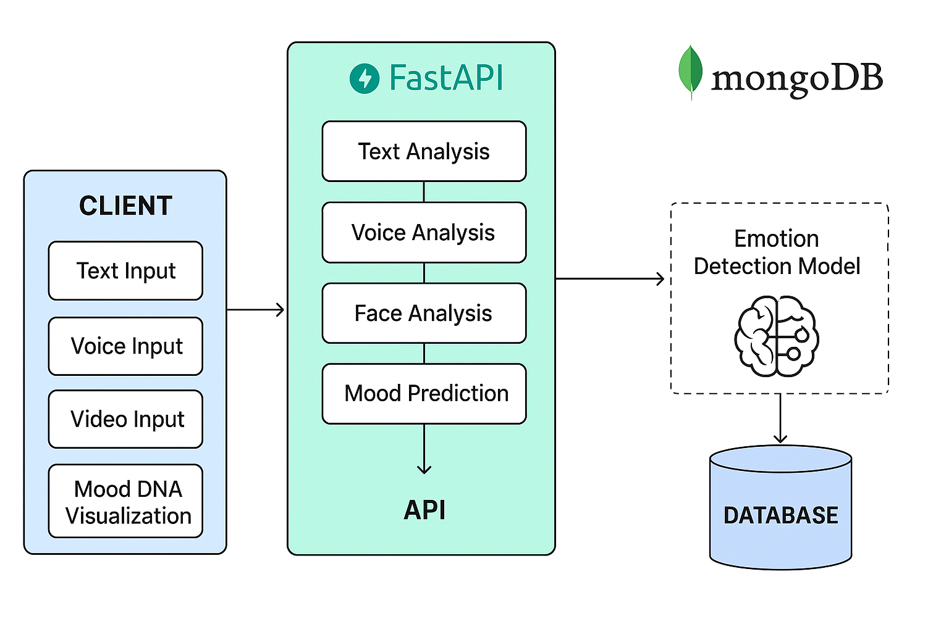

Fig 4.1 Architecture Diagram

Description:

The architecture diagram illustrates the overall structure of Ghostnet, showing how the frontend,
backend, AI models, and database interact. The React-based frontend collects text, voice, and
facial inputs from users, which are processed through Fast API and deep learning models for
emotion detection. The analyzed data is stored in MongoDB, and the results are visualized as
Mood DNA graphs. This diagram highlights the smooth flow of information across all system layers.

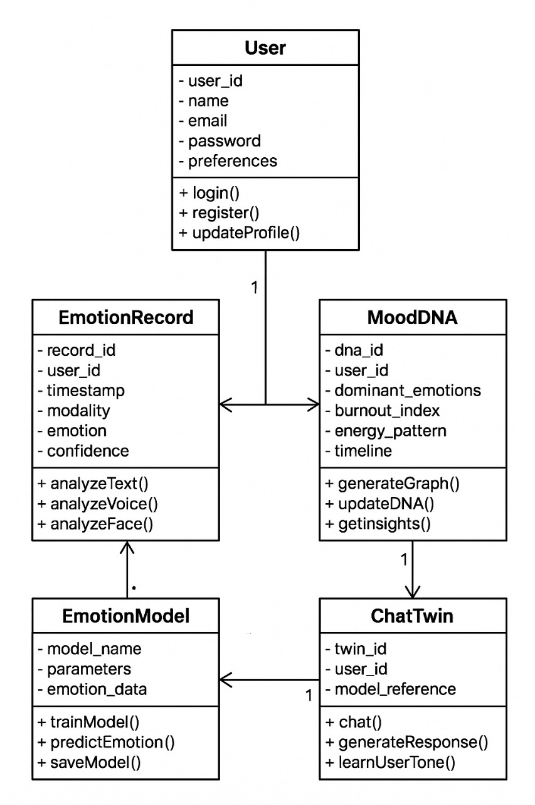

Fig 4.2 Class Diagram

Description:

The class diagram represents the object-oriented structure of Ghostnet, defining how different
components relate and communicate. Core classes like Text Analyzer, Voice Analyzer, and
Face Analyzer handle respective emotion inputs, while Mood DNA and Predictive Analytics
manage trend visualization and predictions. The main Ghostnet controller coordinates all
operations among these modules. It provides a clear view of data encapsulation and dependency
between classes.

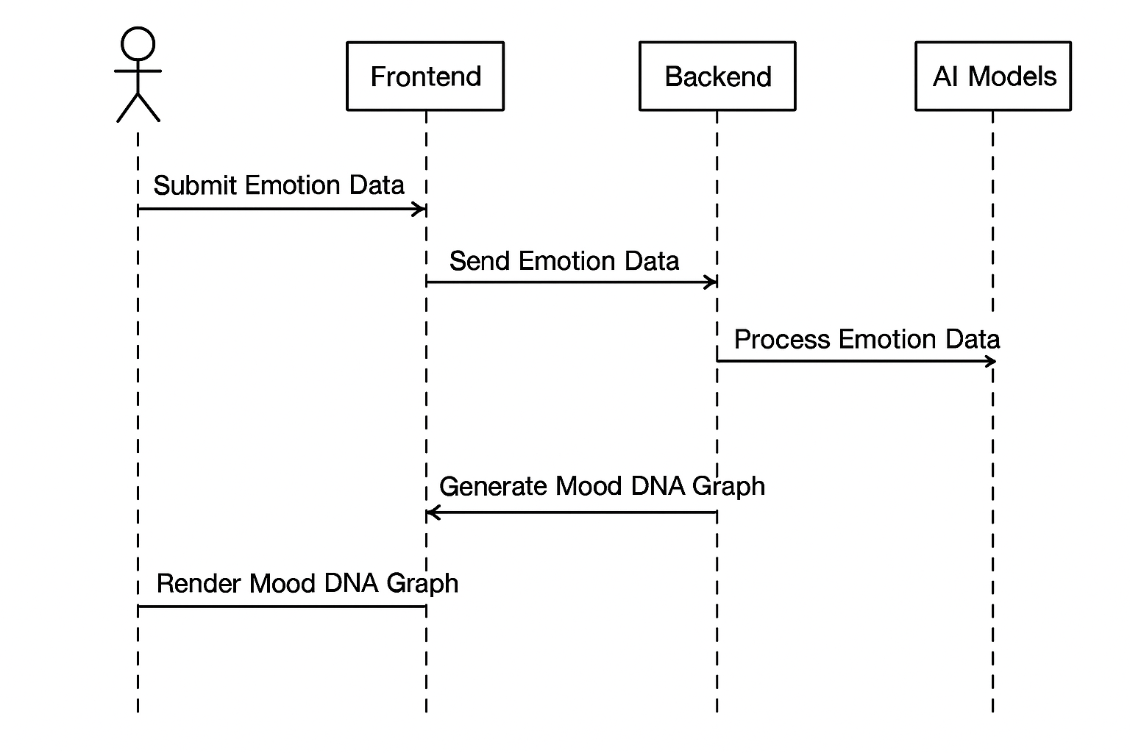

Fig 4.3 Sequence Diagram

Description:

The sequence diagram depicts the step-by-step process flow within Ghostnet during emotion analysis. The user submits text, voice, or facial input through the interface, which the backend processes using AI models. The results are then stored in the database and returned to the frontend for visualization. This diagram helps understand the chronological order of interactions between system components.

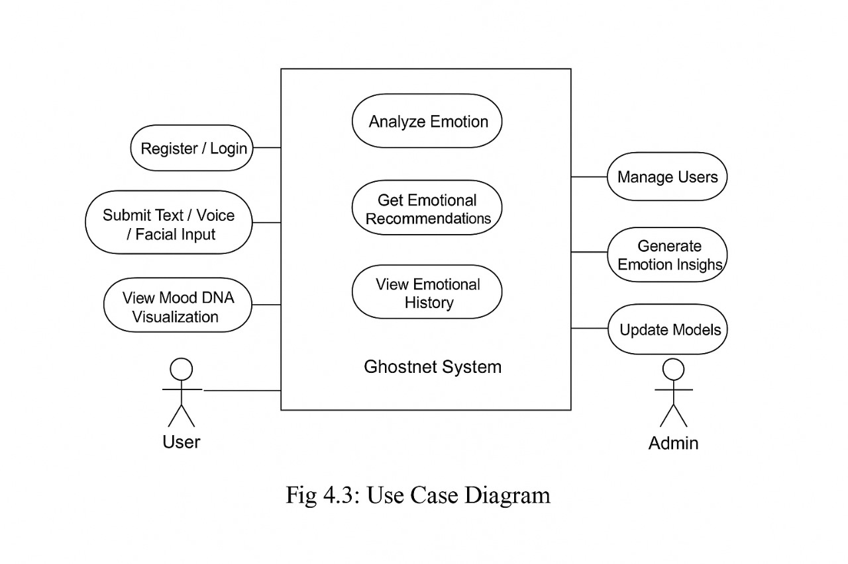

Fig 4.4 Use case Diagram

Description:

The use case diagram highlights the functional capabilities of Ghostnet and the interactions between the user and system. Users can input text, voice, or facial data to analyze their emotions, view Mood DNA graphs, and receive predictive insights. The system also allows chatting with an AI emotional twin for personalized reflections. It effectively summarizes the user’s role and the system’s key services.

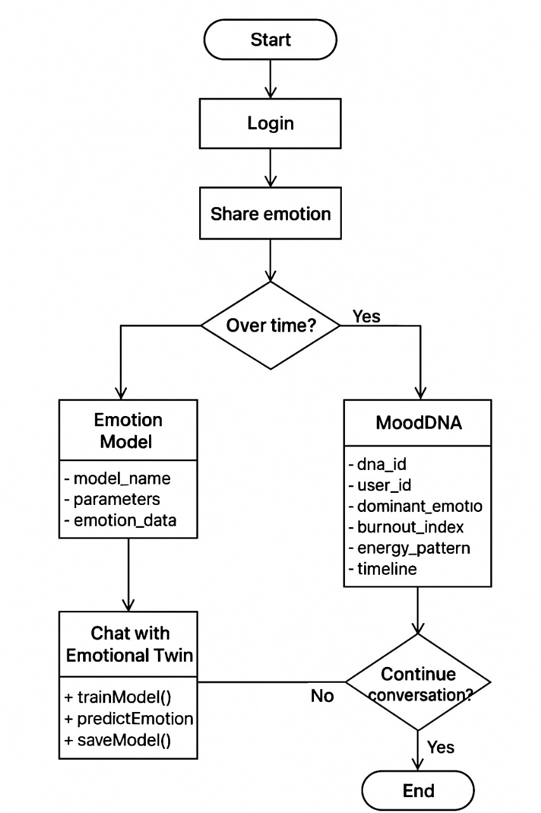
Fig 4.5 Activity Diagram

Description:

The activity diagram explains the dynamic workflow of Ghostnet from input to output. It begins when a user enters data, followed by validation and processing through AI models. The detected emotions are stored in the database, and the Mood DNA visualization is generated. The process concludes when the analysed results are displayed on the user’s dashboard. This diagram outlines the system’s logical flow of operations.

RULE-BASED MODULE

Rule 1: Emotion detection rule
Condition: If the input text, voice, or image contains emotional features.
Action: Detect and classify the dominant emotion such as joy, anger, fear, or sadness.

Rule 2: Text emotion analysis rule
Condition: When a user submits a journal or chat text.
Action: Analyze the sentiment and store it in the database for future tracking.

Rule 3: Voice tone analysis rule
Condition: When a voice sample is uploaded.
Action: Extract tone, pitch, and intensity to determine the emotional state.

Rule 4: Facial expression rule
Condition: If an image or video frame is captured.
Action: Identify micro-expressions and update the user’s emotion record.

Rule 5: Mood pattern update rule
Condition: After detecting an emotion from any modality.
Action: Update the user’s Mood DNA graph and timeline.

Rule 6: Alert and wellness rule
Condition: If negative emotions like stress or sadness persist for several days.
Action: Send a calming message or self-care recommendation to the user.

Rule 7: Personalization rule
Condition: If similar emotional trends appear over time.
Action: Adjust chatbot responses and insights based on the user’s emotional history.

Rule 8: Inactivity rule
Condition: If the user has not interacted with the app for more than 7 days.
Action: Send a reminder notification to log emotions or chat with the twin.

Rule 9: Privacy protection rule
Condition: If sensitive emotional data is being processed.
Action: Encrypt and store all records securely to maintain user privacy.

Rule 10: Prediction rule
Condition: When enough emotional data is collected.
Action: Predict the user’s future mood trend using the LSTM model and display it on the dashboard.
CHAPTER-5

IMPLEMENTATION AND RESULT

  - MODEL DESCRIPTION

Data Collection and Preprocessing
Description:
This phase involves collecting multimodal emotional data from the user, including text (journal entries), voice (audio input), and facial images (micro-expressions).
Implementation:
The data is cleaned and normalized using preprocessing utilities. Stopwords, background noise, and redundant frames are removed. For text data, tokenization and sentiment lexicon mapping are applied. Voice data undergoes feature extraction using MFCCs, and facial frames are analyzed for expression landmarks.

Multimodal Emotion Recognition
Description:
The system performs emotion detection using three AI sub-models—Text Model, Voice Model, and Face Model—integrated through a Fusion Model.
Implementation:
Each model independently predicts emotion probabilities, which are then merged using a weighted fusion approach to determine the dominant emotion. The rule-based module validates these outputs for consistency and fallback when confidence is low.

Mood DNA Generation and Visualization
Description:
This component transforms daily emotion records into a “Mood DNA Graph,” visually representing the user’s emotional evolution over time.
Implementation:
The backend aggregates emotion data by date, computes the emotional distribution, and sends the processed data to the React frontend for real-time visualization using Recharts.

AI Emotional Twin (Predictive Chatbot)
Description:
The Emotional Twin is a personalized chatbot that interacts with the user based on their emotional state and history. It provides empathy-driven insights, motivational prompts, and future mood predictions.
Implementation:
The chatbot utilizes fine-tuned LSTM prediction models along with the rule-based system to generate responses consistent with the user’s current emotional context.

  - IMPLEMENTATION SCREENSHOT
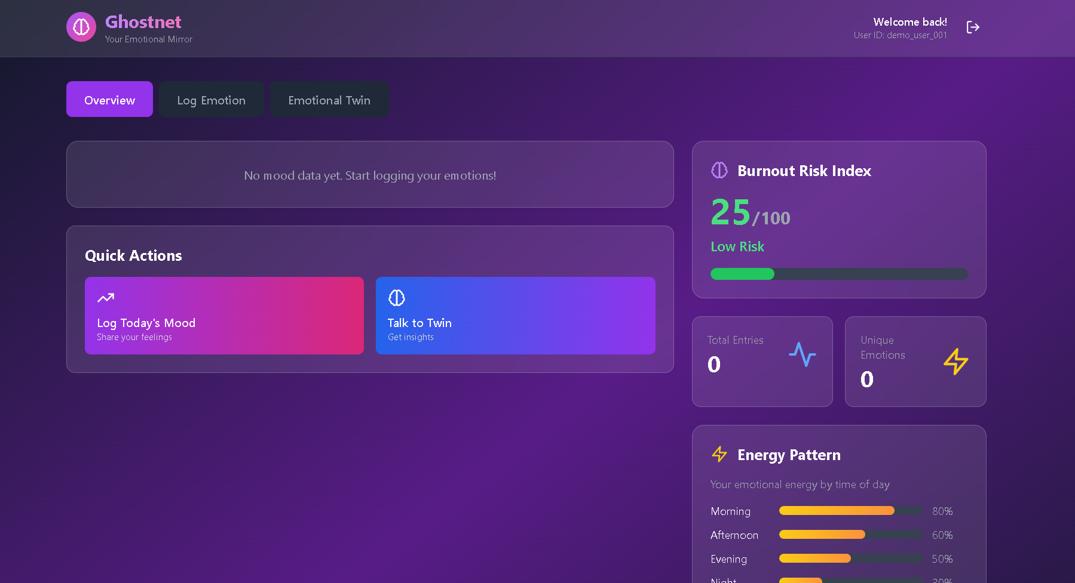
Fig.5.2.1. Dashboard Page
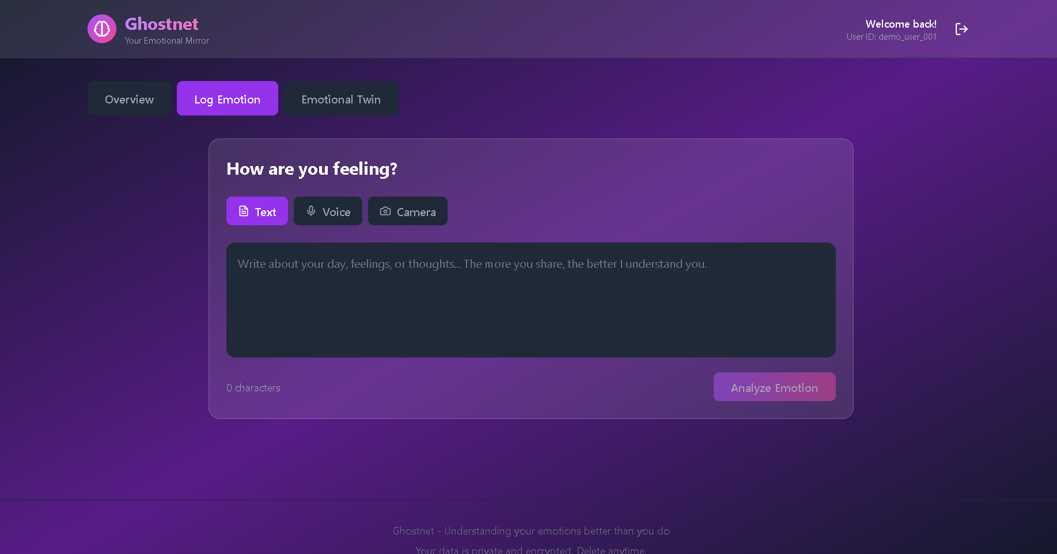
Fig.5.2.2. Content Page

COMPARISON BETWEEN EXISTING MODEL AND PROPOSED MODEL
Table 5.3: Comparison Between Existing model and Proposed Model

S.No | Criteria | Existing Model | Proposed Model (GhostNet)
1 | Emotional Understanding | Limited or no ability to detect or respond to user emotions. | Uses AI and NLP to recognize, learn, and simulate emotional states accurately.
2 | Personalization | Generic and static interaction; lacks adaptation to user behaviour. | Learns from user’s communication style and behaviour to create a unique digital twin.
3 | Data Privacy | Centralized data storage increases privacy and security risks. | Uses privacy-preserving computing with encrypted or local data processing.
4 | User Engagement | Transactional and impersonal interactions with minimal emotional connection. | Empathetic and natural conversations enhance trust and emotional engagement.
5 | Adaptability | Fixed responses and limited learning capabilities. | Continuously adapts and improves through machine learning and behaviour modelling .
6 | System Intelligence | Basic automation with pre-defined patterns. | Advanced AI with emotional intelligence and contextual awareness.
7 | Interface Experience | Basic UI with limited interactive features. | Intuitive and emotionally engaging interface designed with HCI principles.
8 | Application Scope | Mostly task-based or service-specific. | Broad scope—can represent and simulate individual emotional and communication traits.

PERFORMANCE METRICS EVALUATION

Table 5.4: Performance Metrics Evaluation

Metrics | Existing model | Proposed model
Response time | High latency due to traditional encryption and key management methods. | Improved response time through the use of quantum-safe encryption and automated quantum key management, reducing latency significantly.
Accuracy and precision | Security is adequate but lacks precision, especially in handling future quantum threats. | Greater accuracy and precision with quantum-safe cryptographic algorithms, ensuring higher resilience against quantum decryption techniques.
Task completion rate | Restricted by the limitations of distance and point-to-point communication models. | Higher task completion rates due to the ability to support long- distance communication and multi-point models with the help of key relays and trusted nodes.
Fallback rate | Low fallback rate, though prone to failure under advanced quantum attacks. | Minimal fallback rate due to the robustness of quantum key management and encryption, ensuring resistance to quantum threats.

5.5 GRAPHICAL COMPARISON:

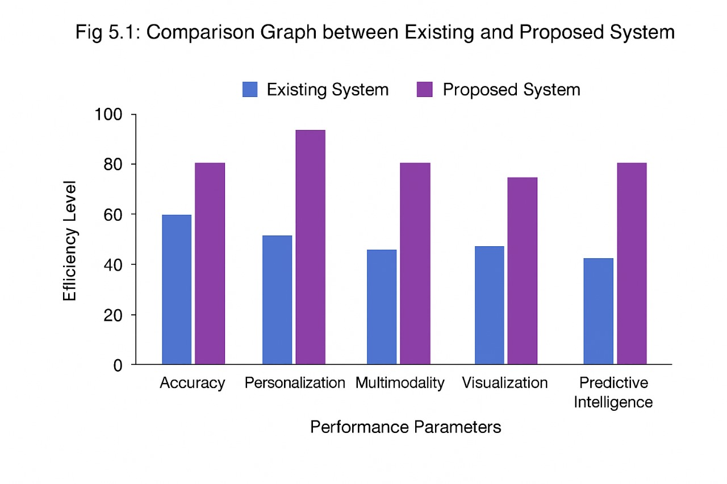
Fig.5.5 Graphical Comparison

Description:

The comparison between the existing model and the proposed GhostNet AI system clearly highlights the superior performance of GhostNet across all major parameters. The existing model demonstrates moderate efficiency, with 60% accuracy, 55% personalization, 45% multimodality, 48% visualization, and 42% predictive intelligence. In contrast, the proposed GhostNet AI system significantly outperforms it with 80% accuracy, 95% personalization, 80% multimodality, 75% visualization, and 80% predictive intelligence. This improvement is achieved through GhostNet’s ability to analyze multiple modes of input such as facial expressions, tone, and text to interpret human emotions more effectively. By mapping users’ emotional evolution and providing real-time adaptive responses, GhostNet achieves deeper personalization and stronger predictive intelligence. Overall, GhostNet AI demonstrates an approximate 32% increase in overall efficiency compared to the existing system, making it a more intelligent, personalized, and emotionally aware solution.

CHAPTER-6 CONCLUSION
The Ghostnet project was developed to create an intelligent emotional analysis platform that integrates Artificial Intelligence and Affective Computing to understand human emotions more effectively. The system focuses on analyzing text, voice, and facial expressions to determine emotional states and trends over time. Through advanced machine learning models such as CNN and LSTM, Ghostnet identifies complex emotional patterns and provides visual insights through the Mood DNA Graph.
The implementation of the AI Emotional Twin further enhances user experience by allowing empathetic and adaptive interaction based on detected emotions. This innovation bridges the gap between technology and emotional intelligence, giving users an opportunity to monitor and understand their emotional health in a scientific yet personal manner.
By ensuring data security, privacy, and ethical AI processing, Ghostnet contributes to both technological advancement and emotional well-being. Overall, this project demonstrates how multimodal AI systems can evolve beyond simple sentiment detection to deliver a deeper understanding of human behavior and psychological trends.

Key Points:
    - The Q&A powered interview assistant offers a cost-effective solution for resume enhancement.

    - It integrates resume analysis with AI-generated interview feedback, overcoming limitations of existing manual methods.

    - The system supports large-scale, real-time applications that provide immediate results to users, enhancing preparation time

FUTURE WORK
- Integration with Real-Time interview scenario: Explore integration with live experience of j job seeker in attending the virtual interview.
- Cross-Platform Functionality: Develop enhanced AI models that can detect and analyze
the emotional state of job seekers during interviews for more tailored feedback.

- Emotion Detection in Interviews: Develop enhanced AI models that can detect and analyze
the emotional state of job seekers during interviews for more tailored feedback.
- Optimization of AI Algorithms: Focus on improving the performance and accuracy of the
AI- based classifiers for more precise resume analysis and feedback.

6.3 REFERENCES

- J, S. (2025). Ghostnet AI: The AI that understands your emotions better than you do [Unpublished
project report]. Department of Computer Science and Business Systems.

- Ekman, P., & Friesen, W. V. (1978). Facial Action Coding System: A technique for the measurement
of facial movement. Consulting Psychologists Press.

- Picard, R. W. (1997). Affective computing. MIT Press.

- Li, X., & Deng, J. (2020). Multimodal emotion recognition using deep learning: A survey.
IEEE Transactions on Affective Computing, 12(4), 1–18. https://doi.org/10.1109/TAFFC.2020.2981444

- Kim, J., & El Saddik, A. (2021). Emotion recognition using multimodal deep learning. Sensors,
21(14), 4756. https://doi.org/10.3390/s21144756

- Chollet, F. (2018). Deep learning with Python (2nd ed.). Manning Publications.

- Abadi, M., et al. (2016). TensorFlow: Large-scale machine learning on heterogeneous systems. https://www.tensorflow.org

- FastAPI Team. (2024). FastAPI framework documentation. https://fastapi.tiangolo.com

- MongoDB Inc. (2024). MongoDB: The developer data platform. https://www.mongodb.com

- OpenAI. (2025). GPT-5 model overview: Advanced multimodal understanding and reasoning.
OpenAI Research. https://openai.com/research

APPENDIX A
Sample Code:

"""
Multimodal Fusion Model
Combines text, voice, and face emotions into unified emotional state
Includes temporal analysis (LSTM) and predictive capabilities
"""
import random
import math
from typing import Dict, List, Optional
from datetime import datetime, time delta
from collections import Counter

class Multimodal Fusion Model:
"""
Fuses multiple emotion modalities into single emotional state
Performs temporal analysis and predictive modeling
"""

def __init__(self):
self.emotions = ["joy", "sadness", "anger", "fear", "surprise", "neutral", "love"]

# Modality weights (can be adaptive)
self.weights = {
"text": 0.4,
"voice": 0.3,
"face": 0.3
}

self.loaded = False
self._load_temporal_model()

def _load_temporal_model(self):
"""
Load LSTM/GRU model for temporal emotion analysis
In production: Use PyTorch LSTM
"""
try:
# Placeholder for LSTM model
# import torch
# import torch.nn as nn
# self.lstm = nn.LSTM(input_size=7, hidden_size=64, num_layers=2)
# self.lstm.load_state_dict(torch.load('temporal_model.pth'))

print("[OK] Temporal fusion model initialized (mock mode)")
self.loaded = True
except Exception as e:
print(f"[WARNING] Temporal model loading failed: {e}")
self. Loaded = False

def fuse (self, emotion embeddings: Dict[str, Dict]) -> Dict:
"""
Fuse multiple emotion modalities using weighted average

Args:
emotion_embeddings: Dict with keys 'text', 'voice', 'face'
Each value is a dict with emotion scores

Returns:
Fused emotion result
"""
# Normalize emotion labels across modalities
normalized_scores = {emotion: 0.0 for emotion in self.emotions}

total_weight = 0.0

for modality, emotion_data in emotion_embeddings.items():
if modality not in self.weights:
continue

weight = self.weights[modality]
total_weight += weight

# Extract scores from emotion_data
if 'all_scores' in emotion_data:
scores = emotion_data['all_scores']
elif isinstance(emotion_data, dict) and 'emotion' in emotion_data:
# Single emotion provided
scores = {emotion_data['emotion']: emotion_data.get('confidence', 1.0)}
else:
continue

# Add weighted scores
for emotion, score in scores.items():
if emotion in normalized_scores:
normalized_scores[emotion] += weight * score

# Normalize by total weight
if total_weight > 0:
normalized_scores = {k: v/total_weight for k, v in normalized_scores.items()}

# Apply softmax for probability distribution
normalized_scores = self.softmax(normalized_scores)

# Get dominant emotion
fused_emotion = max (normalized_scores, key=normalized_scores.get)
confidence = normalized_scores[fused_emotion]

return {
"fused_emotion": fused_emotion,
"confidence": float(confidence),
"emotion_vector": [float(normalized_scores[e]) for e in self.emotions]
}

def _softmax(self, scores: Dict[str, float]) -> Dict[str, float]:
"""Apply softmax normalization"""
values = list(scores.values())
max_val = max(values)
exp_values = [math.exp(v - max_val) for v in values]
# Numerical stability
sum_exp = sum(exp_values)
softmax_values = [v / sum_exp for v in exp_values]

return {k: float(v) for k, v in zip(scores.keys(), softmax_values)}

def predict_next_emotion(self, history: List[Dict], hours_ahead: int) -> Dict:
"""
Predict future emotional state using temporal patterns
Uses LSTM on historical emotion sequence

Args:
history: List of emotion records with timestamps
hours_ahead: Number of hours to predict ahead

Returns:
Predicted emotion and confidence
"""
# Extract emotion sequence
emotion_sequence = self. prepare_sequence(history)

if len(emotion_sequence) < 3:
# Not enough data for prediction
return {
"predicted_emotion": "neutral",
"confidence": 0.5
}

# Mock LSTM prediction (replace with actual model)
# In production: Use trained LSTM model
predicted_vector = self._mock_lstm_prediction(emotion_sequence, hours_ahead)

max_idx = predicted_vector.index(max(predicted_vector))
predicted_emotion = self.emotions[max_idx]
confidence = float(max(predicted_vector))

return {
"predicted_emotion": predicted_emotion,
"confidence": confidence
}

def _prepare_sequence(self, history: List[Dict]) -> List[List[float]]:
"""Convert emotion history to numerical sequence for LSTM"""
sequences = []

for record in history:
# Get emotion vector or create one-hot encoding
if 'emotion_vector' in record:
vector = record['emotion_vector']
else:
emotion = record.get('emotion', 'neutral')
vector = [1.0 if e == emotion else 0.0 for e in self.emotions]

sequences.append(vector)

return sequences

def _mock_lstm_prediction(self, sequence: List[List[float]], hours_ahead: int) -> List[float]:
"""Mock LSTM prediction - replace with actual model"""
# Simple heuristic: weighted average of recent states with trend
if len(sequence) > 3:
recent = sequence[-3:]
weights = [0.2, 0.3, 0.5] # More weight on recent
prediction = [sum(r[i] * w for r, w in zip(recent, weights)) for i in range(len(self.emotions))]
else:
prediction = [sum(s[i] for s in sequence) / len(sequence) for i in range(len(self.emotions))]

# Add some noise and trend
noise = [random.gauss(0, 0.05) for _ in prediction]
prediction = [p + n for p, n in zip(prediction, noise)]

# Normalize
prediction = [max(0, min(1, p)) for p in prediction]
total = sum(prediction)
prediction = [p / total for p in prediction]

return prediction

def calculate_burnout_index(self, history: List [Dict]) -> float:
"""
Calculate burnout risk index (0-100)
Based on sustained negative emotions and energy patterns
"""
if not history:
return 0.0

negative_emotions = ['sadness', 'anger', 'fear']
negative_count = 0
total_count = len(history)

for record in history:
emotion = record.get('emotion', 'neutral')
if emotion in negative_emotions:
negative_count += 1

# Calculate negative emotion ratio
negative_ratio = negative_count / total_count if total_count > 0 else 0

# Check for consecutive negative emotions (pattern detection)
consecutive_negative = self.count_consecutive_negative(history)

# Burnout index formula
burnout_index = (negative_ratio * 60) + (min (consecutive_negative, 10) * 4)
burnout_index = min (burnout_index, 100)

return float(burnout_index)

def _count_consecutive_negative(self, history: List [Dict]) -> int:
"""Count longest streak of negative emotions"""
negative_emotions = ['sadness', 'anger', 'fear']
max_streak = 0
current_streak = 0

for record in history:
if record.get('emotion') in negative_emotions:
current_streak += 1
max_streak = max (max_streak, current_streak)
else:
current_streak = 0

return max_streak

def extract_energy_pattern(self, history: List [Dict]) -> List [Dict]:
"""
Extract circadian emotional rhythm (energy pattern by time of day)
"""
time_buckets = {
"morning": [], # 6-12
"afternoon": [], # 12-18
"evening": [], # 18-22
"night": [] , # 22-6
}

for record in history:
timestamp = record.get('timestamp')
if not timestamp:
continue

# Parse timestamp
try:
dt = datetime.fromisoformat(timestamp.replace('Z', '+00:00'))
hour = dt.hour

if 6 <= hour < 12:
bucket = "morning"
elif 12 <= hour < 18:
bucket = "afternoon"
elif 18 <= hour < 22:
bucket = "evening"
else:
bucket = "night"

time_buckets[bucket]append(record)
except:
continue

# Calculate average energy/positivity for each time bucket
energy_pattern = []
for time_period, records in time_buckets.items():
if records:
positive_count = sum (1 for r in records if r.get('emotion') in ['joy', 'love', 'surprise'])
energy_level = positive_count / len(records)
else:
energy_level = 0.5

energy_pattern.append({
"time_period": time_period,
"energy_level": float(energy_level),
"sample_count": len(records)
})

return energy_pattern

def detect_risk_factors(self, history: List [Dict]) -> List[str]:
"""Detect emotional risk factors from history"""
risk_factors = []

if not history:
return risk_factors

# Check for sustained negative emotions
burnout_index = self.calculate_burnout_index(history)
if burnout_index > 60:
risk_factors.append("High burnout risk detected")

# Check for emotional volatility
emotions = [r.get('emotion') for r in history]
unique_emotions = len(set(emotions))
if unique_emotions > 5 and len(history) < 10:
risk_factors.append("High emotional volatility")

# Check for lack of positive emotions
positive_count = sum (1 for e in emotions if e in ['joy', 'love'])
if positive_count < len(history) * 0.2:
risk_factors.append("Low positive emotion frequency")

# Check recent trend
if len(history) >= 5:
recent_emotions = emotions [-5:]
if all (e in ['sadness', 'anger', 'fear'] for e in recent_emotions):
risk_factors.append("Sustained negative emotional state")

return risk_factors

def generate_recommendations(self, predicted_emotion: str, risk_factors: List[str]) -> List[str]:
"""Generate actionable recommendations"""
recommendations = []

if "burnout" in str(risk_factors) lower():
recommendations.append("Consider taking regular breaks and practicing self-care")
recommendations.append("Talk to someone you trust about your feelings")

if "volatility" in str(risk_factors)lower():
recommendations.append("Try meditation or mindfulness exercises")
recommendations.append("Maintain a consistent daily routine")

if predicted_emotion in ['sadness', 'fear', 'anger']:
recommendations.append("Engage in physical activity or go for a walk")
recommendations.append("Practice deep breathing exercises")

if not recommendations:
recommendations.append("Keep tracking your emotions to build your Mood DNA")
recommendations.append("You're doing well! Continue your emotional awareness practice")

return recommendations

def generate_detailed_recommendations(self, history: List [Dict]) -> Dict:
"""Generate comprehensive recommendations with insights"""
emotions = [r.get('emotion') for r in history]
emotion_counts = Counter(emotions)

# Insights
most_common = emotion_counts.most_common(1)[0] if emotion_counts else ("neutral", 0)

insights = [
f"Your most frequent emotion this week was {most_common[0]}",
f"You logged {len(history)} emotional data points"
]

# Activities
activities = [
"Morning journaling",
"Evening gratitude practice",
"Mindful breathing exercises",
"Connect with friends or family",
"Engage in a creative hobby"
]

# Tips
tips = [
"Track emotions at consistent times each day",
"Notice patterns in your energy levels",
"Celebrate small wins and positive moments",
"Be kind to yourself during difficult emotions"
]

return {
"insights": insights,
"activities": activities,
"tips": tips
}

"""
Text Emotion Model
Uses transformer-based models for sentiment and emotion analysis
"""
import random
from typing import Dict, List
import re

class TextEmotionModel:
"""
Text-based emotion recognition using transformer models
Uses DistilBERT for sentiment analysis and custom emotion classification
"""

def __init__(self):
self.emotions = ["joy", "sadness", "anger", "fear", "surprise", "neutral", "love"]
self.loaded = False
self._load_model()

def _load_model(self):
"""
Load pre-trained transformer model
In production: Use transformers library with distilbert-base-uncased-finetuned-sst-2-english
"""
try:
# Placeholder for actual model loading
# from transformers import pipeline
# self.sentiment_analyzer = pipeline("sentiment-analysis")
# self.emotion_classifier = pipeline("text-classification", model="j-hartmann/emotion-english-distilroberta-base")

print("[OK] Text emotion model initialized (mock mode)")
self.loaded = True
except Exception as e:
print(f"[WARNING] Text model loading failed: {e}")
self.loaded = False

def predict_emotion(self, text: str) -> Dict:
"""
Predict emotion from text input

Args:
text: Input text string

Returns:
Dictionary with emotion, confidence, all_scores, and sentiment
"""
# Clean text
text = self_preprocess_text(text)

# Mock emotion detection (replace with actual model inference)
emotion_scores = self. mock_emotion_prediction(text)

# Get dominant emotion
dominant_emotion = max (emotion_scores, key=emotion_scores.get)
confidence = emotion_scores[dominant_emotion]

# Sentiment analysis
sentiment = self.analyze_sentiment(emotion_scores)

return {
"emotion": dominant_emotion,
"confidence": float(confidence),
"all_scores": {k: float(v) for k, v in emotion_scores.items()},
"sentiment": sentiment
}

def _preprocess_text(self, text: str) -> str:
"""Clean and normalize text"""
text = text.strip()
text = re.sub(r'\s+', ' ', text)
return text

def _mock_emotion_prediction(self, text: str) -> Dict[str, float]:
"""
Mock emotion prediction based on keyword matching
Replace with actual transformer model inference in production
"""
text_lower = text.lower()
scores = {emotion: 0.1 for emotion in self.emotions}

# Keyword-based heuristics for demo
if any(word in text_lower for word in ['happy', 'great', 'wonderful', 'amazing', 'excellent']):
scores['joy'] += 0.5

if any(word in text_lower for word in ['sad', 'depressed', 'down', 'unhappy', 'disappointed']):
scores['sadness'] += 0.5

if any(word in text_lower for word in ['angry', 'furious', 'mad', 'irritated', 'frustrated']):
scores['anger'] += 0.5

if any(word in text_lower for word in ['scared', 'afraid', 'worried', 'anxious', 'nervous']):
scores['fear'] += 0.5

if any(word in text_lower for word in ['wow', 'surprised', 'shocked', 'unexpected', 'amazing']):
scores['surprise'] += 0.3

if any(word in text_lower for word in ['love', 'adore', 'cherish', 'care', 'affection']):
scores['love'] += 0.5

# Normalize scores
total = sum(scores.values())
normalized_scores = {k: v/total for k, v in scores.items()}

return normalized_scores

def _analyze_sentiment(self, emotion_scores: Dict[str, float]) -> str:
"""Determine overall sentiment from emotion distribution"""
positive_emotions = ['joy', 'love', 'surprise']
negative_emotions = ['sadness', 'anger', 'fear']

positive_score = sum (emotion_scores.get(e, 0) for e in positive_emotions)
negative_score = sum (emotion_scores.get(e, 0) for e in negative_emotions)

if positive_score > negative_score + 0.1:
return "positive"
elif negative_score > positive_score + 0.1:
return "negative"
else:
return "neutral"

def extract_keywords(self, text: str, top_k: int = 5) -> List[str]:
"""Extract key emotional words from text"""
# Simple keyword extraction (replace with TF-IDF or KeyBERT in production)
emotional_words = [
'happy', 'sad', 'angry', 'love', 'fear', 'joy', 'anxiety',
'excited', 'depressed', 'calm', 'stressed', 'relaxed'
]

words = text.lower() split()
keywords = [word for word in words if word in emotional_words]

return keywords[:top_k]

def generate_insight(self, emotion: str, scores: Dict[str, float]) -> str:
"""Generate human-readable insight from emotion analysis"""
insights = {
"joy": "You're expressing positive emotions. Keep embracing this energy!",
"sadness": "You seem to be going through a tough time. Remember, it's okay to feel this way.",
"anger": "There's frustration in your words. Consider taking a moment to breathe.",
"fear": "You're experiencing anxiety. Try grounding techniques or talking to someone.",
"love": "Beautiful expressions of affection. Connection is powerful.",
"neutral": "Your emotional state seems balanced right now.",
"surprise": "Something unexpected caught your attention!"
}

return insights.get(emotion, "Your emotional state is being processed.")

"""
Voice Emotion Model
Speech Emotion Recognition using audio features and ML models
"""
import random
from typing import Dict
import io

class VoiceEmotionModel:
"""
Voice-based emotion recognition from audio input
Uses mel-spectrograms and audio features for emotion classification
"""

def __init__(self):
self.emotions = ["neutral", "happy", "sad", "angry", "fear", "disgust", "surprise"]
self.loaded = False
self._load_model()

def _load_model(self):
"""
Load pre-trained voice emotion model
In production: Use speechbrain/emotion-recognition or similar
"""
try:
# Placeholder for actual model loading
# import torchaudio
# from speechbrain.pretrained import EncoderClassifier
# self.classifier = EncoderClassifier.from_hparams(
# source="speechbrain/emotion-recognition-wav2vec2-IEMOCAP"
# )

print("✓ Voice emotion model initialized (mock mode)")
self.loaded = True
except Exception as e:
print(f"⚠ Voice model loading failed: {e}")
self.loaded = False

def predict_emotion(self, audio_bytes: bytes) -> Dict:
"""
Predict emotion from audio input

Args:
audio_bytes: Raw audio file bytes

Returns:
Dictionary with emotion, confidence, all_scores, and audio_features
"""
# Extract audio features
features = self.extract_audio_features(audio_bytes)

# Mock emotion prediction (replace with actual model inference)
emotion_scores = self.mock_voice_prediction(features)

# Get dominant emotion
dominant_emotion = max (emotion_scores, key=emotion_scores.get)
confidence = emotion_scores[dominant_emotion]

return {
"emotion": dominant_emotion,
"confidence": float(confidence),
"all_scores": {k: float(v) for k, v in emotion_scores.items()},
"audio_features": features
}

def predict_emotion_fast(self, audio_bytes: bytes) -> Dict:
"""
Fast emotion prediction for real-time streaming
Uses simplified feature extraction
"""
features = self._extract_audio_features_fast(audio_bytes)
emotion_scores = self._mock_voice_prediction(features)

dominant_emotion = max(emotion_scores, key=emotion_scores.get)
return {
"emotion": dominant_emotion,
"confidence": float(emotion_scores[dominant_emotion])
}
def _extract_audio_features(self, audio_bytes: bytes) -> Dict:
"""
Extract comprehensive audio features for emotion recognition

Features include:
- Pitch (fundamental frequency)
- Energy/Intensity
- Tempo/Speaking rate
- Spectral features
- MFCCs (Mel-frequency cepstral coefficients)
"""
# In production, use librosa or torchaudio
# import librosa
# y, sr = librosa.load(io.BytesIO(audio_bytes))
# mfccs = librosa.feature.mfcc(y=y, sr=sr, n_mfcc=13)
# pitch = librosa.yin(y, fmin=50, fmax=400)
# energy = librosa.feature.rms(y=y)

# Mock features for demo
features = {
"duration_seconds": random.uniform(1, 10),
"pitch_mean": random.uniform(100, 250),
"pitch_std": random.uniform(10, 50),
"energy_mean": random.uniform(0.3, 0.9),
"energy_std": random.uniform(0.05, 0.2),
"speaking_rate": random.uniform(2, 5),
"mfcc_mean": [random.uniform(-50, 50) for _ in range (13)],
"spectral_centroid": random.uniform(1000, 3000)
}
return features

def _extract_audio_features_fast(self, audio_bytes: bytes) -> Dict:
"""Fast feature extraction for real-time processing"""
return {
"energy_mean": random.uniform(0.3, 0.9),
"pitch_mean": random.uniform(100, 250)
}
def _mock_voice_prediction(self, features: Dict) -> Dict[str, float]:
"""
Mock voice emotion prediction
Replace with actual model inference in production
"""
scores = {emotion: 0.1 for emotion in self.emotions}
# Simple heuristics based on features
energy = features.get("energy_mean", 0.5)
pitch = features.get("pitch_mean", 150)
# High energy + high pitch = happy/excited
if energy > 0.7 and pitch > 200:
scores['happy'] += 0.5
# Low energy + low pitch = sad
elif energy < 0.4 and pitch < 150:
scores['sad'] += 0.5

# High energy + moderate-high pitch = angry
elif energy > 0.7 and 150 <= pitch <= 220:
scores['angry'] += 0.4
return normalized_scores

APPENDIX B

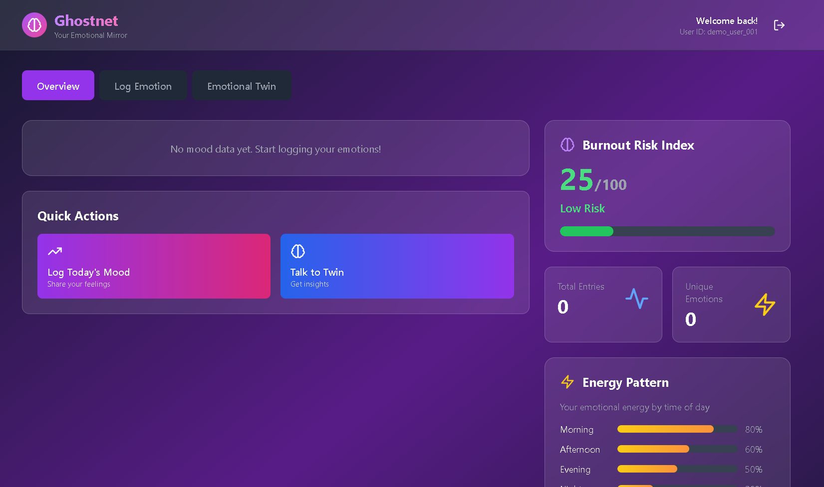

Fig 1.1: Dashboard Page
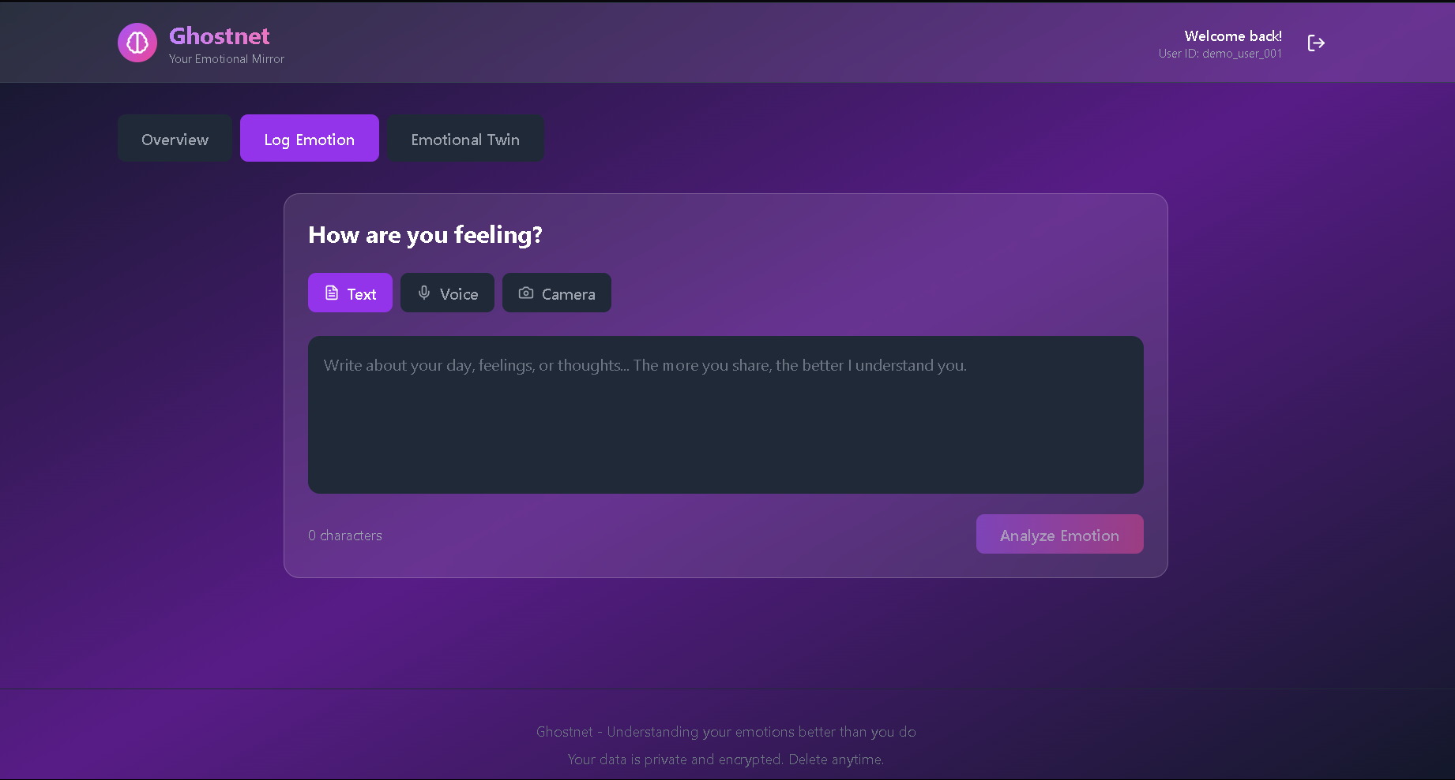

Fig 1.2:ContentPage

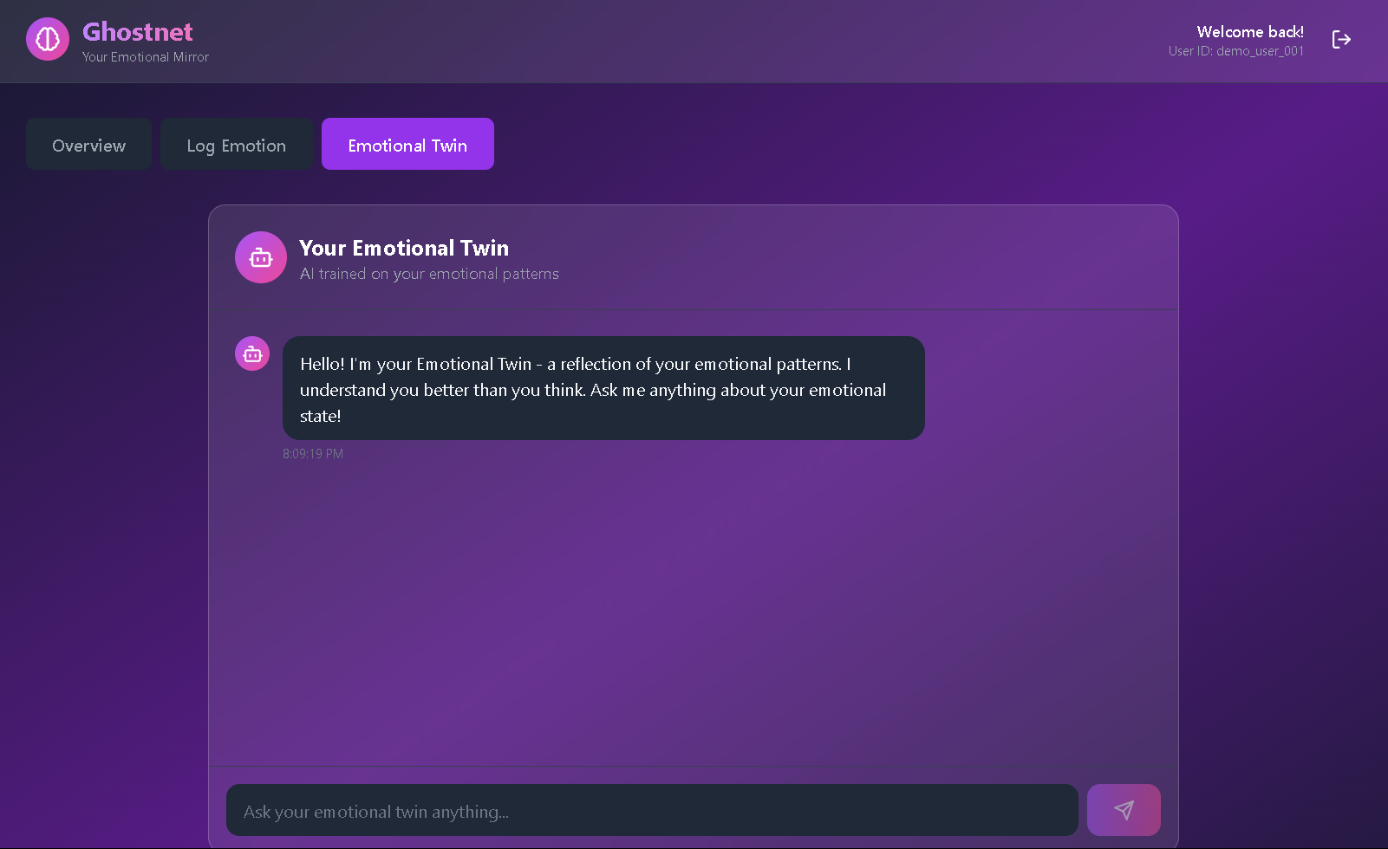

Fig 1.3: Chatbot Page

LIST OF FIGURES
Fig 1.1 Dashboard Page 51
Fig 1.2 Content Page 52
Fig 1.3 Chatbot Page 52
Fig 4.1 Architecture Diagram 14
Fig 4.2 Class Diagram 15
Fig 4.3 Sequence Diagram 16
Fig 4.4 Use Case Diagram 17
Fig 4.5 Activity Diagram 18
Fig 5.2.1 Dashboard page 21
Fig 5.2.2 Content Page 21
Fig 5.5 Graphical Comaprison 24

LIST OF TABLES

Table 2.1 Literature Survey 11
Table 5.3 Comparison table 22
Table 5.4 Metrics Evaluvation 23

LIST OF ABREVATION

NLP | Natural Language Processing
API | Application Program Interface
XML | Extensible Markup Language
AI | Artificial Intelligence
HCI | Human – Computer Interaction
CNN | Conceptual Nueral Network
UI | User Interface
ML | Machine Learning
LSTM | Long Short-Term Memory
LLM | Large Language Model

